Anthony Osita Nwokike

Assignment 1

Cloud Deployment Models and Description of the Azure portal

**Cloud Deployment Models: Public, Private, and Hybrid**

**Introduction:**

Cloud computing has transformed the way organizations manage and store their data. The different cloud deployment models—public, private, and hybrid—offer varying levels of accessibility, security, and management based on organizational needs. Understanding these models is crucial for businesses aiming to leverage cloud technology effectively.

***PUBLIC CLOUD***

A public cloud is a computing service offered by third-party providers over the internet. Resources like servers and storage are shared among multiple organizations, which makes this model highly scalable and cost-effective. Major providers include Amazon Web Services (AWS), Microsoft Azure, and Google Cloud Platform (GCP).

Use Cases

1. Startups and Small Businesses: Public clouds are ideal for startups that require minimal upfront investment. They can access high-end resources without the burden of managing physical infrastructure.

2. Web Applications: Businesses can scale their applications easily during peak times. For instance, an e-commerce site can handle increased traffic during holidays without significant investments in hardware.

3. Development and Testing: Developers can quickly provision and de-provision resources, facilitating agile development and testing processes without long-term commitments.

4. Big Data Analytics: Organizations can leverage vast public cloud resources to analyze large datasets without needing to invest in on-premises solutions.

*PRIVATE CLOUD*

Private clouds are dedicated environments tailored for a single organization. They can be hosted on-premises or by a third-party provider, offering enhanced security and control over data.

Use Cases

1. Regulated Industries: Sectors like finance and healthcare often require strict compliance with regulations. A private cloud provides the necessary security and control over sensitive data.

2. Large Enterprises: Companies with substantial IT budgets may choose private clouds to maintain control over their infrastructure while still enjoying some cloud benefits.

3. Custom Applications: Organizations that need specialized applications can benefit from a private cloud’s flexibility in configuration and deployment, allowing for optimization specific to business needs.

4. Collaboration and Data Sharing: Private clouds can facilitate secure internal collaboration, allowing employees to access and share sensitive data without risking exposure to the public.

*HYBRID CLOUD*

A hybrid cloud combines public and private cloud environments, enabling data and applications to be shared between them. This model provides greater flexibility and optimization of existing infrastructure.

Use Cases

1. Dynamic Workloads: Organizations can run critical applications in a private cloud while utilizing public clouds for less sensitive data or workloads. For example, a company may store its proprietary data on a private cloud while using a public cloud for seasonal data processing.

2. Disaster Recovery: Hybrid clouds can enhance disaster recovery strategies by allowing organizations to back up data in a public cloud while maintaining primary operations in a private environment.

3. Cloud Bursting: Businesses can leverage hybrid clouds for cloud bursting, where they use public cloud resources temporarily to handle surges in demand without investing heavily in private infrastructure.

4. Development and Testing: Organizations can develop and test applications in a public cloud while deploying them in a private cloud, balancing cost and security.

**Conclusion**

The choice between public, private, and hybrid cloud deployment models ultimately depends on an organization’s specific needs, budget, and regulatory requirements. Public clouds offer scalability and cost-effectiveness, private clouds provide enhanced security and control, and hybrid clouds offer flexibility by combining the best of both worlds. Understanding these models allows businesses to make informed decisions that align with their operational goals and strategic objectives in the ever-evolving landscape of cloud computing.

**THE AZURE PORTAL;** The Azure Portal is a web-based application that allows users to manage Azure resources and services. It provides a user-friendly interface for deploying, monitoring, and managing various cloud services. Here’s a guide to navigate the Azure Portal effectively.

Accessing the Portal:

1. Go to portal.azure.com.

2. Sign in with your Azure account credentials.

Main Interface Overview

Once logged in, you’ll see the Azure Portal's main dashboard.

Here are the key components:

Dashboard:

The central area where you can customize your view by pinning frequently used resources and services.

Navigation Menu:

Located on the left side, this menu provides access to various services like Compute, Networking, Storage, and more.

Search Bar:

Use the search bar at the top to quickly find services, resources, or documentation.

Notifications:

The bell icon in the top-right corner shows alerts and updates regarding your resources.

Account Settings:

Access your account details, billing, and subscription information by clicking on your profile icon.

Creating a Resource

To create a new resource, follow these steps:

Click on "Create a resource":

This option is usually found in the top-left corner.

Select a Resource Type:

Browse through categories or use the search bar to find specific services (e.g., Virtual Machine, App Service, SQL Database).

Configure the Resource:

Fill in the necessary details (e.g., name, region, pricing tier) in the configuration wizard.

Review and Create:

After configuring, click on "Review + create" to review your settings. Finally, click "Create" to deploy the resource.

Managing Resources

Resource Groups:

Organize your resources into groups for better management. Click on "Resource groups" in the menu to create a new group.

Monitoring Resources:

Select a resource from your dashboard to view its details. Here, you can monitor performance, set alerts, and access logs.

Deleting Resources:

To delete a resource, navigate to it, click on the "Delete" option, and confirm your action. Be cautious, as this action is irreversible.

Using Azure Marketplace

Explore Marketplace:

Click on "Marketplace" in the left menu to find additional services, applications, and solutions that can be integrated with Azure.

Installing Solutions:

Browse or search for desired applications, then follow the prompts to add them to your Azure environment.

Learning Resources

Azure Documentation:

Access the official Azure documentation for in-depth guides and tutorials.

Azure Learning Paths:

Use the Microsoft Learn platform to find structured learning paths and modules tailored for beginners.

Community and Support:

Engage with the Azure community through forums and support channels for assistance and shared knowledge.

**Fig 1. showing the home page of my Azure account.**

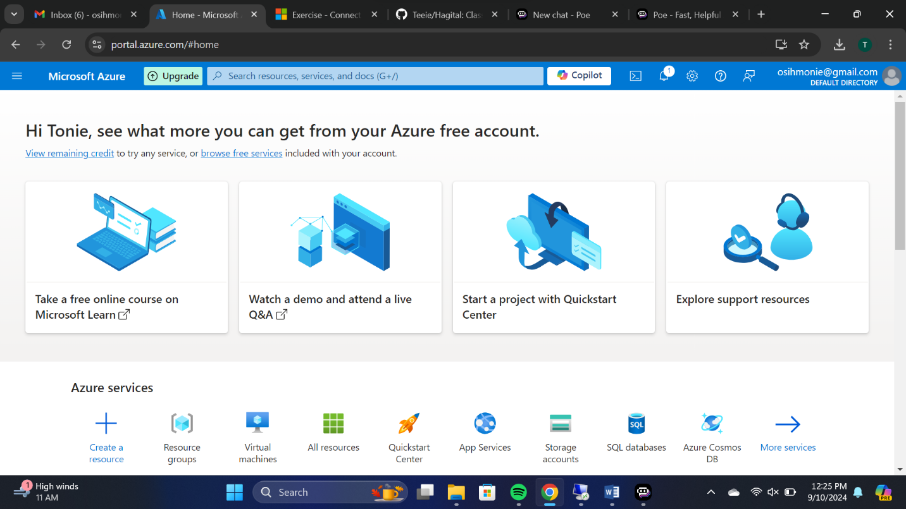

**Fig 2. Showing the option I chose in creating a Virtual machine on the Azure portal.**

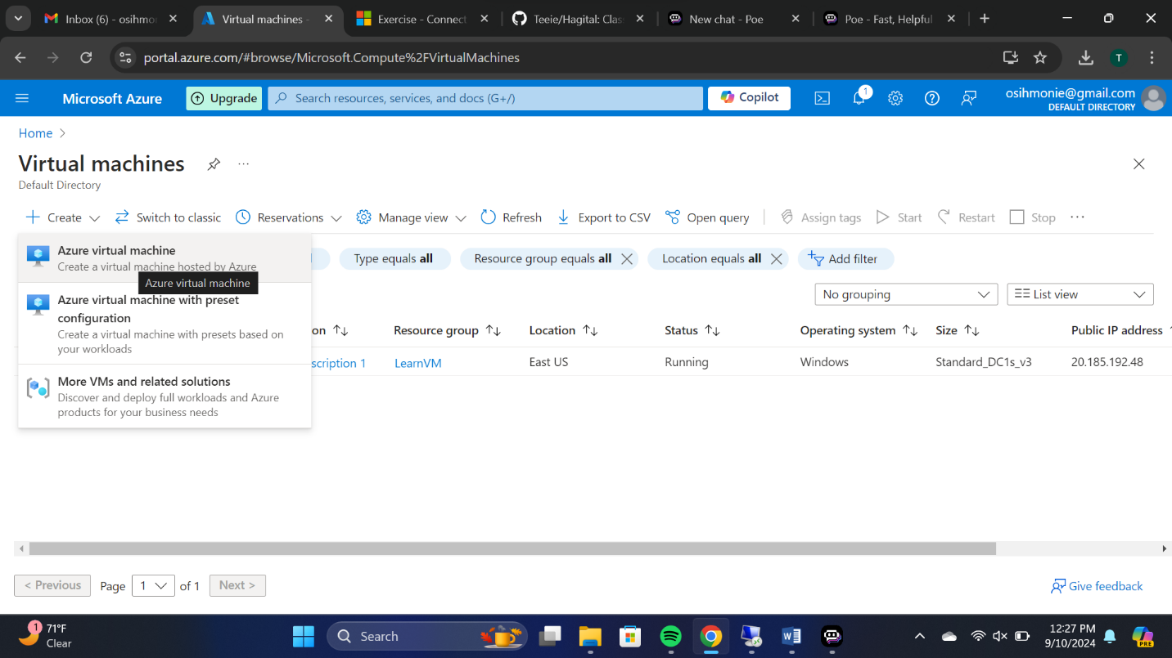

**Fig 3. Showing all the other servises provided by Azure** 